
COMPUTER NETWORKS
EXP 15

November 2, 2021
Roehit ranganathan
RA1911033010017 | L2

PPP CONFIGURATION

Aim:
To implement PPP Configuration using Cisco Packet Tracer.

Diagram:

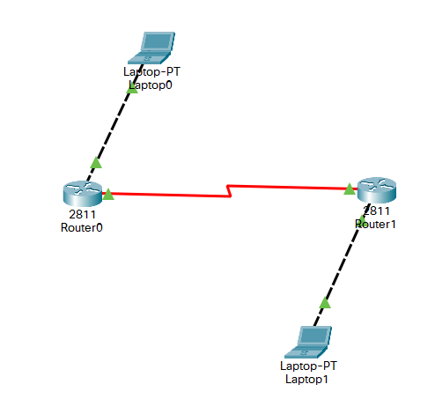

Procedure:
Create the setup as shown in the following figure and configure everything according to it.
Go to the physical tab of each router, turn it off and place WIC-1T in its place and then switch the router on.

1. Use the connected laptops to find the DCE and DTE routers
The show controllers <serial interface> command is used to determine which side of the cable is the DCE side.
In this example, Router-A is the DTE side, and Router-B is the DCE side (DCE V.35, clock rate set).
Router-A#show controllers serial 0/3/0
Interface Serial0/3/0
Hardware is PowerQUICC MPC860
DTE V.35 TX and RX clocks detected

Router-B#show controllers serial 0/3/0
Interface Serial0/3/0
Hardware is PowerQUICC MPC860
DCE V.35, clock rate 2000000

2. Configure the routers with the following parameters

Router-B being the DCE, clock rate has to be configured on Router-B serial 0/3/0 interface

Router-B(config)#interface serial 0/3/0
Router-B(config-if)#clock rate 250000

Then, configure PPP encapsulation and IP address on Router-B serial 0/3/0 interface.
The encapsulation PPP configures PPP protocol on the serial interface.
Router-B being the DCE side of the serial link, the 192.168.10.5/30 IP address is configured on the Router-B serial 0/3/0 interface. Don’t forget to enable the interface with a no shutdown command.

Router-B(config)#interface serial 0/3/0
Router-B(config-if)#encapsulation ppp
Router-B(config-if)#ip address 192.168.10.5 255.255.255.252
Router-B(config-if)#no shutdown

Finally, configure PPP encapsulation and IP address on Router-A serial 0/3/0 interface. The link becomes up as both routers are correctly configured.
Router-A(config)#interface serial 0/3/0
Router-A(config-if)#encapsulation ppp
Router-A(config-if)#ip address 192.168.10.6 255.255.255.252
Router-A(config-if)#no shutdown
%LINK-5-CHANGED: Interface Serial0/0/0, changed state to up
The show interfaces serial 0/3/0 confirms that PPP encapsulation is enabled on the interface: Encapsulation PPP, loopback not set, keepalive set (10 sec)

Router-B#show interfaces serial 0/3/0
Serial0/0/0 is up, line protocol is up (connected)
Hardware is HD64570
Internet address is 192.168.10.5/30
MTU 1500 bytes, BW 1544 Kbit, DLY 20000 usec,
reliability 255/255, txload 1/255, rxload 1/255
Encapsulation PPP, loopback not set, keepalive set (10 sec)
Last input never, output never, output hang never
[...]

3. Check IP connectivity between the two routers using the ping command.

Issue a ping from Router-A to Router-B to test network connectivity between the two routers.

Router-A#ping 192.168.10.5
Type escape sequence to abort.
Sending 5, 100-byte ICMP Echos to 192.168.10.5, timeout is 2 seconds:
!!!!!
Success rate is 100 percent (5/5), round-trip min/avg/max = 3/3/4 ms

Router-B#ping 192.168.10.6
Type escape sequence to abort.
Sending 5, 100-byte ICMP Echos to 192.168.10.6, timeout is 2 seconds:
!!!!!
Success rate is 100 percent (5/5), round-trip min/avg/max = 1/8/22 ms

RESULT:
PPP Configuration is successfully implemented and demonstrated.

